Westlake Cedar Park
300 Beardsley Ln Suite C- 101 301 Denali Pass Dr. Suite 6
Austin, TX 78746 Cedar Park, TX 78613
512-327-5337 512-770-1777

Patient Registration Form

Last Name: _________________________________ First Name: _________________________ M.I.____________

Address: ___________________________________________________________ Apt #____________

City: _____________________________________ State: ________________ Zip: ________________

Cell Phone: ________________________________ Occupation: ________________________________________

Which phone number would you like us to call for appointment confirmation? ______________________________

By what name would you like to be addressed? _______________________________________________________

E-mail address: _____________________________________________ Driver’s License#______________________

Date of Birth: ______________________________ Sex: M / F

Preferred method of contact? (Check all that apply) ______Email ______Text ______Phone ______Mail

Preferred Pharmacy location & phone number: ___________________________________________________________

Reason for consultation: _______________________________________ Referred by: ___________________________

I hereby state that all the facts or information stated herein, including pertinent facts concerning my past medical and surgical
history, as well as any additional information that have been furnished to the treatment provider during my preoperative evaluation, are complete and correct. I certify that all information is correct to the best of my knowledge and I will not hold Jeffrey Hall, MD nor his staff responsible for any errors or omissions that I have made on this form. The treatment provider has explained, in terms clear to me, the effect and nature of the procedure(s) to be performed, foreseeable risks involved and alternative treatment methods. I know that the practices’ of medicine, cosmetics, and lasers are not exact sciences and therefore medical professionals cannot guarantee exact results. I acknowledge that no guarantee or assurance of exact results has been made by anyone regarding the procedure(s) which I have requested and authorized. I have been advised that the goal and results of the procedure(s) that I have requested may not live up to my expectations or to the goals that have been established.

_______________________________________ _____________________
Patient Signature Date

_______________________________________ _____________________
Witness Signature Date

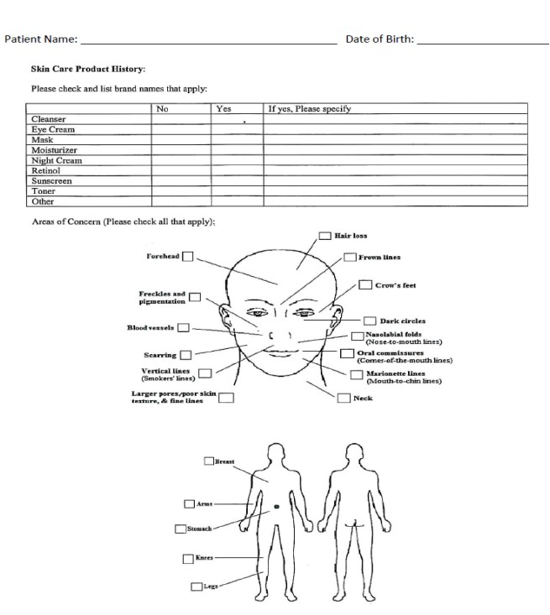

Westlake

Cedar Park

300
Beardsley Ln Suite C-
.

101
301Denali Pass Dr.

Austin, TX 78746 Cedar Park, Tx 78613

512
-
327
-
5337

512
-
770
-
1777

Medical History:

Height: ________ft _________in Weight: _____________lbs Age: ___________ Blood Pressure: _____________

Please Check All That Apply (Current or Past):
None |  | Eczema |  | Kidney Stones/Disease
Abnormal Bleeding |  | Hair Loss/Age first noticed |  | Liver Disease
Anemia |  | Heart Disease |  | Low Blood Pressure
Asthma |  | Heart Murmur |  | Radiation Therapy
Breast Cancer |  | Hernia |  | Skin Cancer
Chest Pain/Tightness |  | High Blood Pressure |  | Skin Disease
Cold Sores |  | HIV |  | Stroke
Colitis |  | Hives |  | Thyroid Disorder
Diabetes |  | Hypoglycemia |  | Tuberculosis
Diverticulitis |  | Keloid/Thick Scarring |  | Ulcers

Past Surgeries/Hospitalizations (if none, please write none):
 | Surgery/Hospitalization | Date | Anesthesia Complications | Notes
None
1
2
3
4
5

Family History (please check all that apply):
 | Check here if applicable | Family Member Affected | Notes
None
Abnormal Bleeding
Anesthesia Problems
Breast Cancer
Malignant Hyperthermia

Please list all drug allergies (check none if none):
Name of Drug: | Reaction:
None

Please list your current medications (check none if none):
Drug: | Dose:
None

Hair Loss Treatments Used (check none if none):
Treatment: | Check if Yes | Length of time used:
None
Rogaine/Propecia
Laser Treatment
Other
Social History:
Do you drink alcohol or have a history of drinking alcohol?
_____No _____Yes If yes, please specify how much/often: _____________________________________

Do you use any illegal drugs or have a history of using illegal drugs? _____No _____Yes If yes, please state what kind/how often:____________________________________

Do you have any sexually transmitted diseases or have a history of sexually transmitted diseases?
_____No _____Yes If yes, please state which one(s):__________________________________________

Do you smoke cigarettes or cigars or have a history of smoking?
_____No _____Yes If yes, please specify how often/how long: __________________________________
Wellness questions:
General: Yes If Yes, Please Specify  None  Convulsions  Depression  Fainting/Dizziness  Fatigue  Fever/Chills  Headache  Insomnia  Nervousness  Sweats | Eyes, Ears, Nose, Throat: Yes If Yes, Please Specify  None  Ear ache  Nose bleeds  Sore throat  Swollen glands  Vision change  Muscle, Bone, Joint  None  Lower back ache  Pain in joints  Respiratory:  None  Chest pain  Chronic cough  Difficulty breathing  Spitting up phlegm
Genito-Urinary: | Yes | If Yes, Please Specify
None
Frequent urination
Incontinence
Painful urination
Prostate trouble

Gastrointestinal: | Yes | If Yes, Please Specify
None
Constant hunger
Constipation
Diarrhea
Gas/bloating
Hemorrhoids
Lack of appetite
Pain over lower stomach/abdomen
Vomiting/nausea

Women’s Health: | Yes | If Yes, Please Specify
None
Hot flashes
Menopause
Painful periods
Pregnant
Births
Miscarriages/Abortions

Patient Photographic Authorization and Release

By signing below, I, _______________________________________________________, authorize Dr. Hall and/or Hall Plastic Surgery & Rejuvenation Center, and/or his/their representative(s), to take photographs, slides or videotapes of me or parts of my body showing before and after results of procedure(s). In addition, I authorize the use of these images, without compensation to me, to be used in the office, for office seminars, on websites owned by or operated on behalf of Hall Plastic Surgery & Rejuvenation Center for prospective patients, in print advertisements, medical presentation, articles, and on television. (This acknowledgement does not pertain to photographs, slides, or videotapes required for medical charts and/or records.)

I understand that:
- Such photographs, slides or videotapes may be published by Dr. Hall and/or Hall Plastic Surgery & Rejuvenation Center in any print, visual, or electronic media including, but not limited to, medical journals and textbooks, scientific presentations and teaching courses, and Internet web sites, for the purpose of informing the medical profession or the general public about plastic surgery methods. I understand that such uses may also include marketing on the behalf of Dr. Hall, for which Dr. Hall may receive direct or indirect remuneration.
- I will not be identified by name in any of the media described above; however, I also understand that in some circumstances the photographs, slides or videotapes may display features that identify me.
- I have the right to revoke this authorization in writing at any time. If I decide to do so, I must present my written revocation to Tricia Hall (Privacy Officer). A revocation shall not affect any release of information made prior to revocation in reliance upon this authorization.
- I may refuse to sign this authorization without such refusal affecting the medical treatment I receive from Dr. Hall and/or Hall Plastic Surgery & Rejuvenation Center.
- The information disclosed under this Authorization, or some portion thereof, is protected by state law and/or the federal Health Information Portability and Accountability Act of 1996 ("HIPAA"). Any disclosure of information carries with it the potential for an unauthorized secondary disclosure and the information may not be protected by applicable federal and/or state confidentiality rules.
- A copy of this Authorization is valid as the original. I may inspect or copy information to be used or disclosed under this authorization, as provided by federal and/or state law.
I release and discharge Dr. Hall and/or Hall Plastic Surgery & Rejuvenation Center from all photographic liability, including photographic liability for negligence that in any way arises out of any and all rights that I may have or may have had in the photographs, slides or videotapes of me that I have authorized to be used and disclosed in this Authorization; and any claim that I may have had relating to such use and disclosure of those photographs, slides or video tapes of me, including any claim for payment in connection with any distribution or publication of them in any medium. This Authorization is made as a voluntary contribution in the interest of public education and I certify that I have read this Authorization and Release carefully and fully understand its terms.
[ ] Patient is a minor, _________ years of age, and we, the undersigned, are the parents or guardian of the patient and do hereby consent for the patient.

Signature: _____________________________________________________________ Date: _____________________

Printed Name: ____________________________________________________________________________________
[ ] Decline to give consent, please initial.

Financial Polices

________ I understand that Hall Plastic Surgery and Rejuvenation Center does not accept nor file any type of health insurance benefits. Any and all costs for surgical and/or nonsurgical procedures must be paid in full at the time of services rendered, unless otherwise noted.

_______ Services may be prepaid and remain on a patient’s account for up to one year. Pre-purchased merchandise or services may not be refunded, transferred to another account, nor used as credit.

_______ I understand that I will be charged a fee of $30.00 for any returned checks or insufficient payments.

_______ We will keep you informed of any outstanding balances that could occur. Any balance not paid by 60 days after the service date will be forwarded to our collections agency. In the case of default of payment, you will be responsible for any collections cost or reasonable attorney fees incurred to satisfy this account.

APPOINTMENT NO SHOW POLICY

Hall Plastic Surgery requires a credit card on file and consultation fee of $75 for reservations with Dr. Hall. Fees will be applied to services rendered, and will not be refunded for any reason. Should you not attend your scheduled appointment, fees will be considered a “no show” fee and will not be available as credit for services.

Hall Rejuvenation Center requires a credit card on file to book appointments. Nonsurgical consults are complimentary. Hall Rejuvenation charges a $50 fee for appointments not cancelled or changed at least 24 hours prior to the scheduled appointment.

*Appointments with Dr. Hall exclude surgery, as those have their own requirements for scheduling and cancellation.

Also, please note that patients who arrive late 15 minutes or more for any appointment, may be asked to reschedule depending upon provider availability.

______ I have read the above policies and agree to them.

_____________________________________________________ _______________________________
Signature Date

Acknowledgement of Review of Notice of Privacy Practices

I have reviewed this office’s Notice of Privacy Practices, which explains how my medical information will be used and disclosed. I understand that in order for my medical information to be shared with any family member, they must be designated as such below. I understand that I am entitled to receive a copy of this document.

______________________________________________
Signature of Patient or Personal Representative

________________
Date

______________________________________________
Name of Authorized Personal Representative

______________________________________________
Description of Personal Representative’s Authority

